Unit Naming
The BUG mod includes the Generic Unit Naming (GUN) mod. This mod is designed to give the player an extremely flexible method of naming his units. The basic approach is that the player constructs a naming convention that they want to use (see later) and then assigns that naming convention to all units, all units of the same combat type or all units of the same unit type in the same era.
The options shown on the BUG mod’s Unit Naming option screen are shown below.
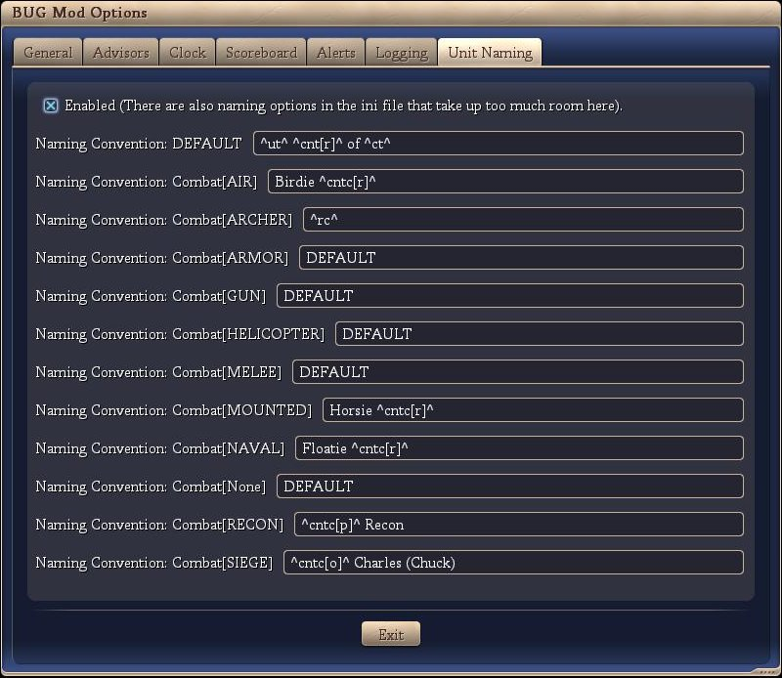
These features are discussed below:
- Enabled
If this option is checked, then the unit naming portion of BUG is enabled and units produced will be given a name depending on the player defined naming convention. If this option is not checked, then the unit naming portion of BUG is not enabled and default Civ4 unit naming will occur.
- Use Advanced
If checked, than the unit naming code will extract the naming convention from the BUG mod ini using the unit type and the current player era. If this naming convention is “DEFAULT”, then the naming convention associated with the unit’s combat type will be used. If this naming convention is “DEFAULT”, then the ‘default’ naming convention will be used.
For example: An axe constructed in the ancient era will use the naming convention stored with the ini key “AXE_ANCIENT”. If this naming convention is “DEFAULT”, then the naming convention stored with the ini key “Melee” will be used. If this naming convention is “DEFAULT”, then the naming convention stored with the ini key “DEFAULT” will be used.
If this option is not checked, then the naming convention associated with the unit’s combat type will be used. If this naming convention is “DEFAULT”, then the ‘default’ naming convention will be used.
- The balance of the screen shows the various naming conventions used for the 10 combat types in the game. An 11th quasi-combat type (None) has been added for settlers, workers, missionaries, etc.

Naming Conventions
The following is the code that controls the name that your unit will have.
- ^civ4^ - no naming convention, uses standard civ4
- ^rd^ - random name
- ^rc^ - random civ related name
- ^ct^ - City
- ^cv^ - Civilization
- ^ut^ - unit (eg Archer)
- ^cb^ - combat type (Melee)
- ^dm^ - domain (Water)
- ^ld^ - leader
- ^cnt[f]^ - count across all units (increments based on unit)
- ^cntu[f]^ - count across same unit (increments based on unit)
- ^cntct[f]^ - count across same city (increments based on unit)
- ^cntuct[f]^ - count across same unit / city (increments based on unit)
- ^cntc[f]^ - count across same combat type (increments based on combat type)
- ^cntd[f]^ - count across same domain (increments based on domain)
- ^tt1[f][x:y]^ - total where the total is a random number between x and y (number)
- ^tt2[f][x]^ - total count (starts at x, incremented by 1 each time ^tt1 is reset to 1)

There are a number of number formats, as follows:
- [f] can be either 's', 'A', 'a', 'p', 'g', 'n', 'o' or 'r' for ...
  - silent (not shown)
  - upper case alpha (A, B, C, D, ...)
  - lower case alpha (a, b, c, d, ...)
  - phonetic (alpha, bravo, charlie, delta, echo, ...)
  - greek (alpha, beta, gamma, delta, epsilon, ...)
  - number
  - ordinal (1st, 2nd, 3rd, 4th, ...)
  - roman (I, IV, V, X, ...)

Some number formats have a built in max (i.e. alpha). In these situations, the numbering loops back to the start. For example, if you pass the number ‘30’ and ask for the number to be formatted with an ‘A’ (upper case alpha) then it will return ‘D’.

